pg. 1

2021-2022

Classroom Support Team Overview
Madrid Neighborhood School
&
Granada East

Table of Contents

Introduction 3
Classroom Support Team Role Descriptions 4
Classroom Support Team Contributors 5
About the District 6
Key Findings and Accomplishments 8
Madrid Neighborhood School & Granada East Impact………………………………………… 9-13
Classroom Support Team Surveys 14
Student Testimonials 15
Teacher Reflections 16-17
References 18

About Million Dollar
Teacher Project
About Million Dollar Teacher Project: The Million Dollar Teacher Project, a registered 501 (c) 3 since 2016, is dedicated to impacting student performance through teachers. Arizona teachers voluntarily leave the profession at rates 85% higher than the national average. Our students within Arizona and throughout the country deserve better - with our innovative, scalable and cost-effective solutions, we work to resolve issues within teacher support, recognition, and compensation. We're changing the culture around teaching while creating tangible, data-driven solutions that help teachers get back to the most important parts of their jobs: growing the globe's future leaders.

Mission: Elevate the teaching profession through increased recognition, compensation, and support.

Vision: Creating a world where every student experiences excellent education every day.

Intro to the Classroom Support Team
Intro to the classroom support team Teachers cite compensation, support, and recognition as the top three reasons they exit the profession. Million Dollar Teacher Project's Classroom Support Team (CST) seeks to directly impact the support system surrounding teachers.
In traditional classrooms, teachers work far beyond their job descriptions, juggling delivery of content, technology support, relationships with parents, emotional and behavioral issues, special education plans - the time investment is often overwhelming.
Why would we be content with a stressed, overwhelmed individual teaching our children? We can help to transform our teachers' experiences, and therefore their students' achievements, by better supporting educators.

The Classroom Support Team assists with tech integration, student teaching, parent engagement, and teacher assisting. Each team works with a grade level for maximum efficacy.

The Classroom Support Team
Bringing together all the areas of need into an innovative solution for real support.

The Teacher
Within the Classroom Support Team, the teacher is supported with resources, staff, and data. With this new help, teachers focus on high-needs students and have room to get back to the most important parts of their jobs: helping kids.

Technology Integration
The intern/volunteer collaborate with teachers to bring impactful technology practices into the classroom. With this technology, the specialists analyze data on student performance and behavior to communicate to the teacher where special attention is needed.

Parent Engagement
Community involvement in the classroom and investing in teachers creates a healthy, collaborative space for their students. The Parent Engagement Specialist keeps parents updated and works to strategically engage them in the teacher’s work in the classroom.

Student Teacher
Student teachers are valuable partners for teachers and schools. While helping to engage more students in the classroom, the host school has an opportunity to preview what the student might be like as a potential full-time employee. The student teacher assists with lesson planning, classroom management and curriculum implementation.

Teaching Assistants/Interns
Having an eager, willing set of extra hands in the classroom can shift busy work time away from the teacher. Teaching Assistants/Interns gain insight into classroom management/instruction and experience while enabling the teacher to engage in activities that require a certified educator. The assistant works with students 1-on-1 and in strategic groups.

Classroom Support Team Members and Partners

Madrid Neighborhood School:
Arizona State University: Patrick De Leon - University Service-Learning & Educational Studies | Community Engagement Programs, Hahnna Christianson Internship and Experiential Learning Coordinator Academic Support
Arizona State University: University Service learning ( USL) and Interdisciplinary studies(IDS)
Third Grade Teachers: Sarah Messick and Sophie Brugere
Principal: Stacy O’Rourke
CST Members: Martha Patrick, Michelle Houchins, Isabelle Hauter, Nolan Marshall

Granada East:
Arizona State University: Patrick De Leon - University Service-Learning & Educational Studies | Community Engagement Programs, Hahnna Christianson Internship and Experiential Learning Coordinator Academic Support
Special Education teachers: Rhonda Bowman, Katherine Malone, Kari Stratman, Sylvia Walsh, Beverly Shondee
Principal: Melvin Mitchell
CST Members: Evan Powell, Morgan Lanius, Nolan Marshall

About the School District
Alhambra Elementary School District
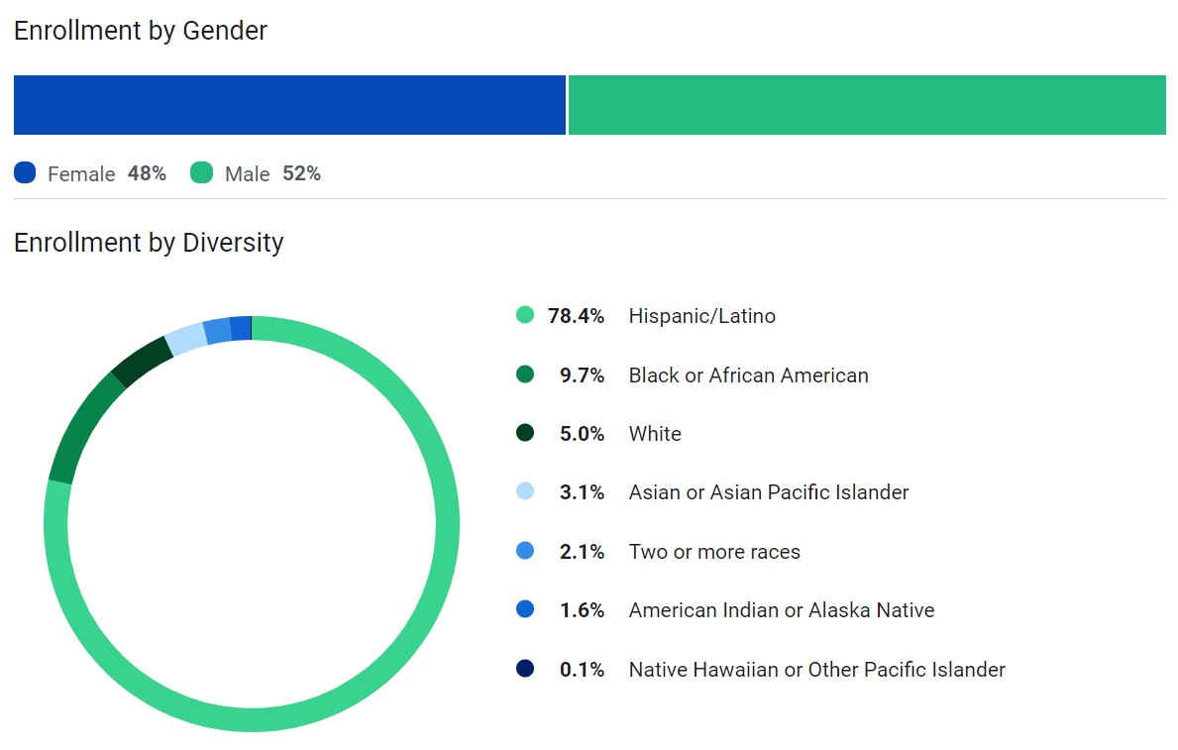
Madrid Neighborhood & Granada East
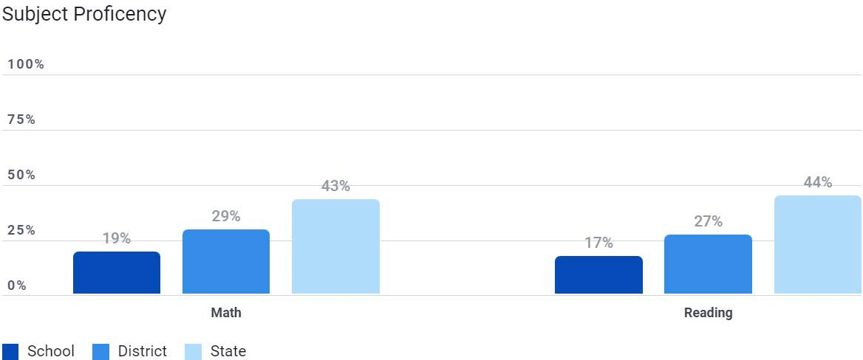
Alhambra Elementary District

Sixth Year
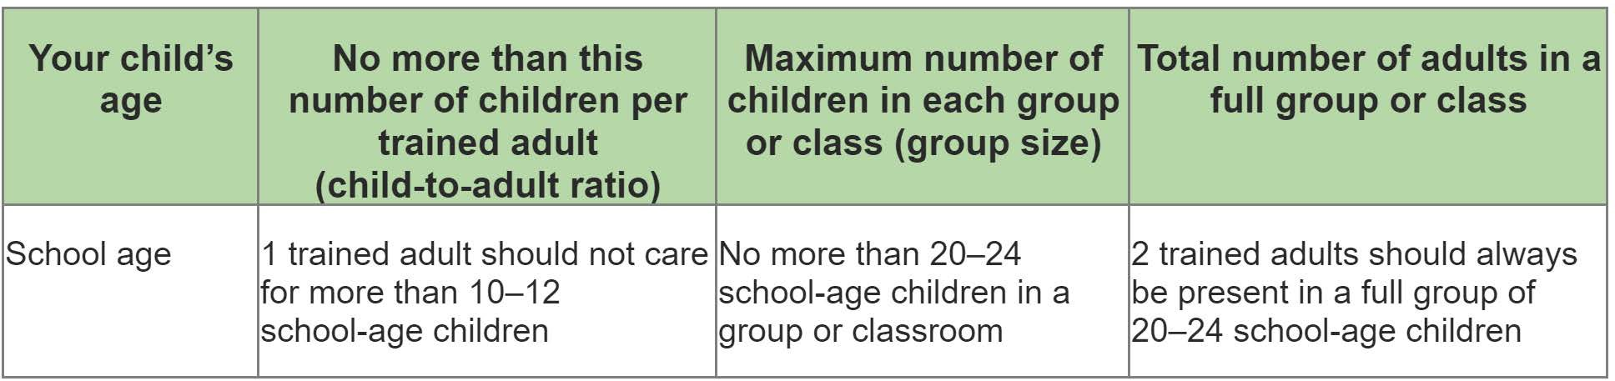
In the Million Dollar Teacher Project’s sixth year of operation, we took a three pillars immersive approach to the school we worked with. We focused all of our attention on Recognition, Compensation and Support on the Madrid Neighborhood School in Alhambra Elementary School District. Over the 2021 – 2022 school year from September 1st to March 31st we were in session. MDTP started the year planning to provide teams for the third and fifth grade classrooms. Due to Covid-19 we only worked the third grade. Our CST members started in Fall of 21 and continued into Spring 22 with our Third-grade class at Madrid, where the classroom ratios rose to 30+:1, this is a statewide trend in title1 schools. MDTP was able to give these classrooms continued support.

Sited:Ratios and Group Sizes | Childcare.gov

In the past we brought in individuals to focus on certain areas within the classroom. MDTP saw the value in incorporating all the areas/needs into one person instead of trying to find multiple individuals. This has been hugely beneficial to the needs of the teachers in the classrooms. One intern is able to now take care of helping with technology, assisting the teacher with classroom needs such as grading, filing or copying, and at the same time run one on one groups, as well as act as an assistant teacher.
At the beginning of the new year we got a call from a MDTP vetted teacher at Granada East middle school. She was requesting support for the Special Education Department (Sped). Due to Covid regulations at Madrid we were unable to bring on more interns to support other classrooms. So we were able to take interns that were on our waitlist to Granada East and support five teachers on their campus as well.
SpEd Departments are often overlooked, underfunded, and overwhelmed with students needing a lot of individualized support. Our interns were from a wide array of backgrounds, and this diversity ccontributed greatly to their work. Their presence made a huge impact not only on the needs of the teachers but also on the achievement of the students.
What we have found this year Is COVID-19 has had a profound impact on the educational system whether that is academically, emotionally, mentally, or physically. Students are very far behind, and teachers are very overwhelmed.

In the past we brought in individuals to focus on certain areas within the classroom. MDTP saw the value in incorporating all the areas/needs into one person instead of trying to find multiple individuals. This has been hugely beneficial to the needs of the teachers in the classrooms. One intern is able to now take care of helping with technology, assisting the teacher with classroom needs such as grading, filing or copying, and at the same time run one on one groups, as well as act as an assistant teacher.
At the beginning of the new year, we got a call from a MDTP vetted teacher at Granada East middle school. She was requesting support for the Special Education Department (Sped). Due to Covid regulations at Madrid we were unable to bring on more interns to support other classrooms. So we were able to take interns that were on our waitlist to Granada East and support five teachers on their campus as well.
Sp-Ed Departments are often overlooked, underfunded, and overwhelmed with students needing a lot of individualized support. Our interns were from a wide array of backgrounds, and this diversity contributed greatly to their work. Their presence made a huge impact not only on the needs of the teachers but also on the achievement of the students.
What we have found this year Is COVID-19 has had a profound impact on the educational system whether that is academically, emotionally, mentally, or physically. Students are very far behind, and teachers are very overwhelmed.

Key Findings and Accomplishments
- Thanks to additional support from the Classroom Support Team, we were able to make a difference. Due to covid, allowed hours were restricted for safety through CDC regulations. With the combined contributions of our team, 400 hours of their time was given back to teachers at Madrid Neighborhood and 300 hours of their time was given back to Granada East teachers. A combined total of 700 hours was given back to both schools in the Alhambra Elementary School District. This enabled teachers more time to contribute to other areas of their work in the class or in their personal lives.
- Teachers who participated reported that CST team members made classroom operations run smoother and reduced stress.
- Teacher testimonials:
  - “Again, I cannot say this enough...the help that Ms. Morgan and Mr. Evan are giving our students is a gift. They are patient, highly effective and when I get assistance with the small group portion of my resource time, everyone benefits!”
- “The CST Team has been beyond my expectations. With little direction from me, both Ms. Morgan and Mr. Evan were 100% engaged and the students enjoy working with them. If I could have a CST Team member with me, during 4th, 5th, and 6th hours of our day, our students would benefit in ways that cannot be captured with words. Thank you
- “The CST team keeps students focused and on task. Students come with a lot of emotions and sometimes it is good to help keep them focused on a goal.”
- Participating CST members were able to explore the profession and make evaluations of their career choices with the experience they received.
  - “I just want to reiterate that the faculty at MDTP and the faculty at Granada East we're very helpful in helping me figure out where I want my career to go and this internship experience has been the most formative experience educationally in my four years at Arizona State. I stand for everything that MDTP represents and I hope to see the program grow from here. I will be teaching elementary math in the phoenix area and if it weren't for my experience here I may be doing something entirely different so I really am indebted to the program and I'm willing to help facilitate its growth in the future.” Nolan Marshall CST
- Student teacher’s being hired after program completion. This year we had one educationally focused intern. Our Team collectively had a desire to give back to the community through the classroom.
  - One CST member has taken a position with Teach For America to teach math in the fall.
  - One CST member has taken a position at Madrid Neighborhood School as a part-time teacher in their new resource program.
- Cost Effectiveness with the MDTP is clear. Our team contributed a total of 700 hours between our two campuses. With a campus dealing with a large amount of 2-week quarantines of teachers, staff and students throughout the school year, qualified engaged hands are priceless. The estimated in-kind value contributed by our team this year, is $10,500. Our CST members were motivated and ready to get involved. One of our CST members was hired as a part-time teacher at the Madrid Neighborhood School. Her involvement in the CST qualified her and gave everyone the opportunity to see her abilities in action. She is continuing her education at ASU to be a school counselor. She gets to see the difference teachers make daily, working as a teacher while she finishes her degree.

Madrid Neighborhood School &
Granada East

Overview/Highlights

- Participating teachers reported the CST involvement helped control behavioral problems with students and keep their focus on learning.

- Participating teachers reported that they were able to focus on teaching and the “big picture” of their classroom thanks to CST involvement.

- CST members felt like they had a better understanding of the educational profession and felt like the experience was positive for the teachers, students, and themselves.

- Student centered data
- Madrid:
- - 72.4% of students, on average, reported feeling good or better.
- - 79.1% of students, on average, reported getting an A as their highest grade, while only 5 students reported a D or F as their highest grades.
- - 25.1% of students, on average, reported getting a D or F as their lowest grade.

- Granada East:
- - 69.2% of students, on average, reported feeling good or better.
- - 38.5% of students, on average, reported getting an A as their highest grade, while no students reported a D or F as their highest grades.
- - 15.4% of students, on average, reported getting a D as their lowest grade, no students reported an F as their lowest grade.

- Teacher centered data

- - Throughout the program, teachers were excited to come into work a staggering 93% of the time.
- - They also reported having more free time 70% of the time.
- - Participating teachers found the CST improved their teaching experience 92.9% of the time this school year.
- - Teachers reported a decrease in negative student behaviors 35% of the time.
- - Teachers reported that having a support team member in the classrooms changed the atmosphere to promote better learning and reduced stress.
- - Teachers enjoyed the chance for their students to interact with new adults in the classroom.
- - Teachers reported that a new adult in the classroom helped reset behavioral issues as students were more likely to behave well with CST members.

Overview Madrid Reading Math Highlights
Class A
aReading Test (reading comprehension)
Fall Average: 460
Spring Average: 478

CBMReading (reading fluency)
Fall Average: 58 words per minute
Spring Average: 88 words per minute

aMath (math comprehension)
Fall Average: 193
Spring Average: 199

CBMMath Automaticity (math fluency)
Fall Average: 3
Spring Average: 18

Class B
aReading Test (reading comprehension)
Fall Average: 463
Spring Average: 484

CBMReading (reading fluency)
Fall Average: 49 words per minute
Spring Average: 84 words per minute

aMath (math comprehension)
Fall Average: 196
Spring Average: 199

CBMMath Automaticity (math fluency)
Fall Average: 4
Spring Average: 20

Madrid Neighborhood – Sarah Messick

Sarah Messick is a powerful 3rd grade lead teacher at Madrid Neighborhood School. As a lead teacher she handles a lot of responsibility. This year Ms. Messick’s classroom had 31 students. She had multiple quarantine disruptions with 6 to 8 students being out for two weeks as a covid precaution. With a classroom of returning students that had been home for the last year and a half, she was facing a lot of unknowns. The third graders were new first graders last time they were in the classroom. MDTP was honored to be apart of her year and have an impact on her classroom.

A few words from Ms. Messick:

The biggest challenge I faced this year in the classroom is supporting a large class with a wide range of academic and emotional needs. The pandemic has been a traumatizing experience for us all, and for children, trauma can significantly impact their ability to learn. I struggled with feelings of inadequacy because I couldn’t be everywhere at once, and I couldn’t meet every child’s unique needs at the same time.

The Million Dollar Teacher Project really helped me be a stronger teacher this year. The in-classroom support meant that I could focus less on organizing paperwork or grading assignments and instead focus more on teaching the students in front of me. My students developed a strong connection with my classroom volunteer as well, and when they needed some one-on-one attention or assistance, she was right there to support them. It had a huge impact on the culture, climate, and success of my classroom this year.

My students inspire me every day with their enthusiasm, work ethic, and resiliency. This past year was a challenging one, but my students showed up every day eager to learn and do better, and you can’t help but be inspired by that! I am inspired to teach because I believe that education is empowering. It is a privilege to get to help children reach their fullest potential every day.

Granada East – Rhonda Bowman
The CST team keeps students focused and on task. Students come with a lot of emotions and sometimes it is good to help keep them focused on a goal.
~ Rhonda Bowman

Mrs. Bowman, a former CST Teacher from Granada East, contacted MDTP to ask for support for her Special Ed Team. We were excited to be able to put a team together for them.

Mrs. Bowman has been teaching for 14 years. She currently teaches the 7th and 8th graders in a self-contained classroom. She is a true professional in how she carries herself in the classroom and inspires her students. She specializes in special education and students with intellectual disabilities. Her students are multiple grade levels behind in state testing and she has worked tirelessly to help them greatly improve. She is a model teacher and a role model to many on campus.

A few words from Mrs. Bowman:

I am inspired by the idea of wanting to have a better world. I want to surround myself with better people and I know with teaching it’s important to me that we have young adults that are prepared. I want my students to be able to do something they love and take care of themselves.
Some families value education differently than others, and rightly so, so sometimes education is not one of their top priorities. This can be a challenge sometimes but MDTP has really helped in this regard.

MDTP is great because the people come in and understand the ins and outs of a classroom. Sometimes we are teachers, parents, counselors etc. They fill many roles and I really love that MDTP offers us an opportunity to form better relationships and better communication with the parents. The students benefit because they see another adult who cares about them and they appreciate this which also makes my life a lot easier. Many hands make the load light.

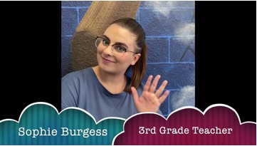
What Our Teachers saying?
Impact Video ~ Ms. Burgess 3rd Grade
When asked, “What has motivated you to participate in this program and redesign your curriculum?”
Teachers answered:
-”I am motivated to participate in this program because it is important to work with others towards a common goal of increasing student success and teacher support.”
-”The high number of students in my class and lack of help and resources.”
-”I wanted to be able to meet my students' needs better by having additional support to reach each kid where they're at. Having a volunteer in my classroom has ensured that my students all get some individual attention, which has made a huge difference in our class culture and the growth we were able to make this year.”

When asked, “What benefits did you receive from being in this program of a support team?”
Teachers answered:
-“Grades done more quickly and on time, classroom support with the students, occasional provided food/prizes, classroom side work could get done”
-”On the days that I had my support volunteer, there was a noticeable change in the atmosphere of the classroom. I was able to focus more on providing instruction because I had another person there to support specific struggling students or help manage behavior. My students' growth in reading and math was significantly better this year, and I attribute a lot of this to the one-on-one attention they received in class. It also eased a lot of my stress to have the additional support with grading and general paperwork, so that I was able to focus more on planning and delivering quality instruction.”
-”My students and I received support in the classroom from a team of volunteers/interns by helping to carry out my lesson plans and strengthening strategies my students need to acquire the standard being taught. We all made friends and the students also received the opportunity to interact with another caring adult.”

Pre-Survey Post
-100.0% of teachers felt like they had time to collaborate with fellow colleagues.
-40% felt like teachers are protected from duties that interfere with their abilities to educate students.
-100% of teachers disagreed that class sizes are reasonable such that teachers have the time available to meet all the needs of the students. A Teacher shared a challenge: On the days that I had my support volunteer, there was a noticeable change in the atmosphere of the classroom. I was able to focus more on providing instruction because I had another person there to support specific struggling students or help manage behavior. My students' growth in reading and math was significantly better this year, and I attribute a lot of this to the one-on-one attention they received in class. It also eased a lot of my stress to have the additional support with grading and general paperwork, so that I was able to focus more on planning and delivering quality instruction.
-80% of teachers felt like they had sufficient access to appropriate instructional materials.
-83.3% felt like they had sufficient access to instructional technology, including computers, devices, printers, software and internet access.
-75% of teachers felt like parents/guardians were NOT influential decision makers in their schools.
-The teachers were neutral on the idea that their schools maintained clear two-way communication with the community.
-100% of teachers thought that the community they served supported their schools.

-75.0% of teachers felt like they had time to collaborate with fellow colleagues.
-50% felt like teachers are protected from duties that interfere with their abilities to educate students.
-100% of teachers disagreed that class sizes are reasonable such that teachers have the time available to meet all the needs of the students. A Teacher shared a challenge: My 32 students have many different needs that I alone cannot address in my classroom. Having an additional support person will help ensure that all students get the support they need to be successful.
-80% of teachers felt like they had sufficient access to appropriate instructional materials.
-85% felt like they had sufficient access to instructional technology, including computers, devices, printers, software and internet access.
-83.3% of teachers felt like parents/guardians were NOT influential decision makers in their schools.
75% -The teachers felt that their schools maintained clear two-way communication with the community.
-90% of teachers thought that the community they served supported their schools.

been employ

*Pre- survey was completed early September

*Post survey was completed at the beginning of April

Student Testimonials

Student Testimonial
Students were asked how they felt/what they liked during the weeks CST members were active in the classrooms and they answered with a variety of responses such as:
“Learning to read.”
“I like school.”
“Good because I love science so much.”
“I felt confident.”
“This week felt little bit good and tiny bit tired.”
“I feel great because I’m happy.”
“I’m happy.”
“I feel great.”
“I felt good because I love the school 😁.”
“Good because I love my school and my teacher.”
“I felt excited because I was happy to learn new things.”
“I felt excited because we are going to do new things.”
“I feel happy because I’m at school and I’m so excited To learn . 😇”
“This week I felt good because I learned new things.”
“I felt happy because in the weekend I read a lot of books 📚 I am getting faster.”

Students are excited for school! They love to learn and they thrive in environments where learning is enjoyable. Those environments are fostered when students are given individual attention, which isn’t always possible for one-teacher classrooms.

Teacher’s Reflection

“My students and I received support in the classroom from a team of volunteers/interns by helping to carry out my lesson plans and strengthening strategies my students need to acquire the standard being taught. We all made friends and the students also received the opportunity to interact with another caring adult.” Rhonda Bowman, Granada East.

“They were not in my class very often. Mr. Evans was in my classroom about 4 times and he was great! He connected with the students and jumped right in!” Beverly Shondee, Granada East.

“On the days that I had my support volunteer, there was a noticeable change in the atmosphere of the classroom. I was able to focus more on providing instruction because I had another person there to support specific struggling students or help manage behavior. My students' growth in reading and math was significantly better this year, and I attribute a lot of this to the one-on-one attention they received in class. It also eased a lot of my stress to have the additional support with grading and general paperwork, so that I was able to focus more on planning and delivering quality instruction.” Sarah Messick, Madrid.

“The CST Team has been beyond my expectations. With little direction from me, both Ms. Morgan and Mr. Evan were 100% engaged and the students enjoy working with them. If I could have a CST Team member with me, during 4th, 5th, and 6th hours of our day, our students would benefit in ways that cannot be captured with words. Thank you for sharing these wonderful students with me!!!” Sylvia Walsh, Granada East.

“Evan and Morgan were very helpful. They always come in ready to get started and with a smile on their faces. The kids are happy to see them and enjoy working with them as well. They are self starters and seem to know when to jump in to help a student, which is extremely helpful.” Kari Stratman, Granada East.

“Isabella has been incredible to have in the classroom. With her now here Mondays, Wednesdays, and Fridays from the late morning until the end or even after school, I am able to pull more small groups, have her walk around the room and help students when I cannot get to them, and grade work while I am teaching. She has also been helpful with completing student benchmarks and progress monitoring as she can pull individual students during regular instructional time. She has also helped to create files for work, individual students, and prepared copies for the day and next week that I would normally have to stay after school to do for hours. If I had help like her everyday during the full day, I would be able to have someone well-versed in classroom management and academics that could help pull consistent small groups and upkeep progress monitoring. It is also extremely helpful to have another set of eyes and ears that can catch student behaviors that I miss while dealing with other things.” Sophie Brugere, Madrid.

“Morgan and Evan are excellent at popping into the lesson and helping students who they can see are struggling without me having to ask them. It takes some of the burden off of me because my students have high academic needs.” Katherine Malone, Granada East.

“Once again, Ms.Morgan, Mr. Evan, and Mr. Nolan help my SPED students in so many ways. All three CST members readily jump in--with little direction. GREAT EXPERIENCE for my students and me!” Sylvia Walsh, Granada East.

Teacher’s Reflection Cont.

“The CST team keeps students focused and on task. Students come with a lot of emotions and sometimes it is good to help keep them focused on a goal.” Rhonda Bowman, Granada East.

“I had a few severe behavioral incidents this week. Martha was invaluable in keeping my students safe! She has built strong relationships with the students, which helps calm them down and keep them focused when I am not able to work individually with them. Academically, we saw a large increase in our reading foundational test scores this week, with 70% of students passing compared to a previous average of around 50%. This is in part due to Martha's support with individual students during instruction time, so that I am able to reach the needs of all learners.” Sarah Messick, Madrid.

“Michelle and I were able to finish the library and organize the books into baskets with labels so the students were really excited to use the books, and they managed to keep it clean. Nolan also came briefly and was able to hang up my bulletin board and my students' beginning of the year posters. They loved being able to point them out and see their work displayed, which is something that is usually put off when I do it myself because I have to prioritize grading and other works.” Sophie Brugere, Madrid.

“It was really helpful having Martha in my classroom this week because we had to give individual progress monitoring assessments to each student. Rather than me trying to manage the class AND pull students one at a time for testing, I was able to continue teaching as usual while Martha pulled the students to test.” Sarah Messick, Madrid.

References

  - Alhambra Elementary District (4280) - U.S. News Education (usnews.com)
  - Ratios and Group Sizes | Childcare.gov

